EXPERIMENT - 6 Snort IDS/IPS Using TryHackMe
Aim
To understand and demonstrate the working of Snort as an Intrusion Detection System (IDS) and Intrusion Prevention System (IPS) by detecting real-time network threats using the TryHackMe platform.
Procedure:
Step 1: Login to Platform
Open TryHackMe in a browser and log in using your account.
Step 2: Open Snort Room
Search for a Snort-related room and join it to begin the experiment.
Step 3: Start AttackBox
Launch the AttackBox, which provides a ready-to-use Linux environment for performing the tasks.
Step 4: Verify Snort Installation
Open the terminal and confirm that Snort is installed and ready to use.
Step 5: Run Snort in IDS Mode
Start Snort in detection mode so that it monitors network traffic and generates alerts for suspicious activity.
Step 6: Detect Network Threats
Perform the tasks given in the room and observe how Snort identifies and reports potential threats in real time.
Step 7: Configure IPS Mode
Enable prevention mode to allow Snort to block malicious traffic based on predefined rules.
Step 8: Analyze Alerts
Review the alerts generated by Snort and identify different types of network attacks.

Output:

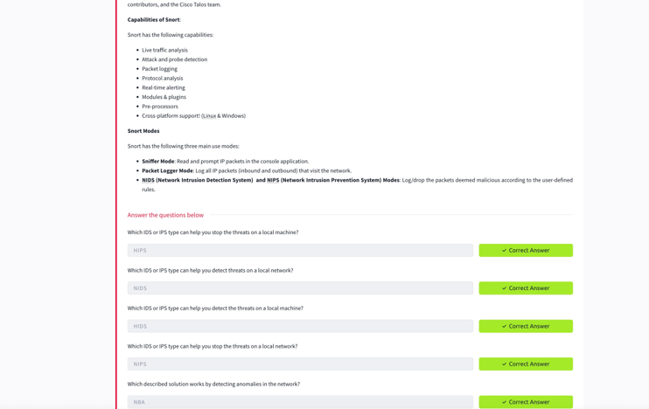

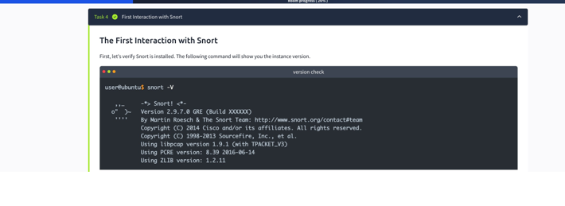
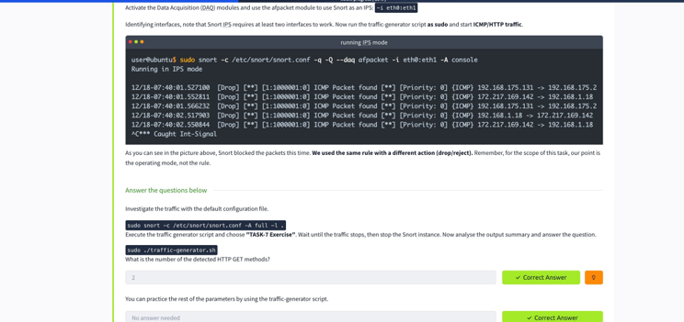
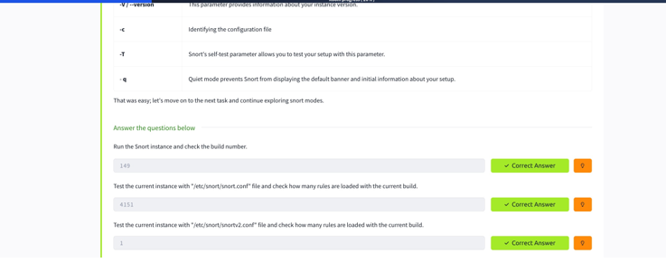

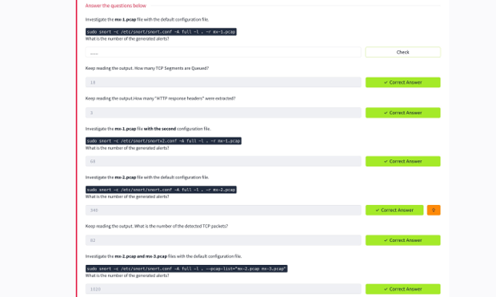

Result
Snort was successfully used as an IDS/IPS to detect and prevent network threats, demonstrating real-time network security monitoring in a controlled environment.

